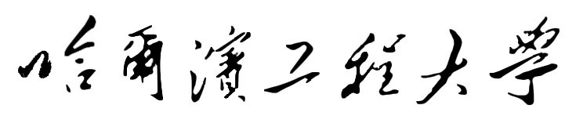
外国留学生奖学金申请表
APPLICATION FORM FOR HEU SCHOLARSHIP
本页由奖学金申请人本人逐项认真填写/The applicant will carefully fill in the following parts.
请申请人认真阅读注意事项后再填写下列各项/Please read CAREFULLY the NOTE before filling out the form.
姓名(同护照用名)/Applicant’s Name(Same as in Passport):
姓/Family Name:
名/Given Name: Middle Name:
性别/Sex: 出生日期/Date of Birth: ________年/Year 月/Month 日/Day
出生国(地区)/Country(Region) of Birth:
国籍/Nationality: 护照 / Passport No.:
学生类别/Student Category:
本科生/Undergraduate □ 硕士研究生/Postgraduate □ 博士研究生/Doctorate □
培养单位/School or College:
学习专业/Study or Research Field:
本人申请的奖学金为/The scholarship I wish to apply for (Please Check):
全额奖学金/Full Scholarship □ 免学费/Free Tuition; 生活费补贴/Living expense.
一等奖学金/First prize Scholarship □ 免全部学费/Free tuition
二等奖学金/Second prize Scholarship □ 免50%学费/50% deduction from tuition fees
学习期限为/From ______ 年/Year 月/Month 至/to ______ 年/Year 月/Month
奖学金申请理由/Self-statement for applying the scholarship
Please explain what difference receiving this scholarship would make to your life.

其它课外活动或科研成果（如空格不够，请附另页）
Extracurricular activities or academic achievements（Use additional sheet if needed）

推荐单位或个人/References
姓名/Full name 职称/Title
工作单位/Organization 电子邮件/E-mail
地址及电话号码/Address & Tel

个人声明:/Declaration
- 上述情况真实无误。/All information in this form is true and correct.
- 在哈尔滨工程大学学习期间遵守中国政府的法律和哈尔滨工程大学的规章制度。/ I shall abide by the laws of the Chinese government and the regulations of HEU during studying at HEU.

本人签字/Signature: _______________ 日期/Date: _______年/Year ____月/Month _____日/Day
注意事项 / Note:
1. 请申请人用中文或英文填写，其他文字或缺项的申请表无效；需在本表相应框内做出选择的地方，请用符号“”表示。/ This form is to be completed by the applicant in Chinese or English only. Any incomplete application or application completed in languages other than Chinese or English will be invalid; Please use “” to check the box in the relevant items to indicate your selection.

